ADVENTURE WORKS · TECHNICAL SUPPORT

Saddle Height, Slipping, or Creaking Seatpost
Saddle & Fit Document TS-012 Rev. A
Applies to | All Adventure Works models
Difficulty | Beginner
Time required | 10 – 25 minutes
Tools needed | 4 / 5 mm hex key, Torque wrench, Grease or carbon paste, Tape measure

Symptoms
- The saddle slowly drops during a ride.
- A creak from under the saddle when pedaling.
- The saddle tilts or twists out of position.
- Knee discomfort from a saddle set too high or too low.
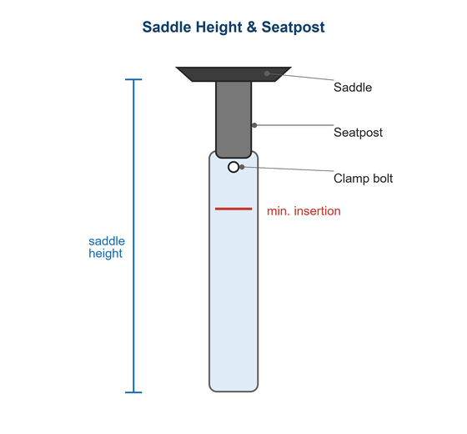
Figure 1. Mind the minimum-insertion mark and set the correct saddle height.

Likely Causes
- Seatpost clamp under-torqued or the post is greasy where it shouldn't be.
- Carbon post or frame assembled without carbon paste.
- Dry saddle-rail clamp creaking under load.
- Incorrect saddle height for the rider.
- A damaged or mismatched-diameter seatpost.
Safety first
- Never raise the post above the minimum-insertion line — it can crack the frame or post.
- Use grease on alloy posts and carbon paste on carbon interfaces; over-greasing carbon causes slipping.
- Torque the clamp to spec; over-tightening can crush a lightweight post.

Customer Fix — Step by Step
Suitable for home repair with basic tools. Work through the steps in order.
- Set saddle height: with the heel on the pedal at the bottom of the stroke, your leg should be straight; it bends slightly when pedaling with the ball of the foot.
- Mark or note the insertion depth, and confirm the post is past the minimum-insertion line.
- For slipping, remove the post, clean it, and apply grease (alloy) or carbon paste (carbon) to the clamp zone only.
- Reinsert to your mark, level the saddle, and torque the seatpost clamp to spec.
- For a creak, also remove, clean, and lightly grease the saddle-rail clamp bolts and re-torque.
- Sit and pedal hard to confirm the saddle holds position and is quiet.

Technician Reference
Additional checks and adjustments for service technicians and advanced users.
- Verify the seatpost diameter matches the frame (e.g., 27.2 / 30.9 / 31.6 mm) and isn't relying on a worn shim.
- Inspect the post and frame collar for cracks or deformation, especially around the slot.
- For dropper posts, check the actuation, air pressure, and bushing play per the maker's guide.
- Apply friction paste for carbon and confirm the clamp closes evenly without pinching.
- Set rail clamp torque to spec and confirm rails sit in the clamp's allowed zone.

Torque & Specifications
Fastener / setting | Specification
Seatpost clamp | 5 – 7 N·m
Saddle rail clamp | 5 – 7 N·m
Carbon interface | Use carbon paste
Insertion | Past minimum mark
Heel-on-pedal | Leg straight at bottom

Figure 2. Keep the post inserted past the minimum-insertion line at all times.
Pro tips
- Record your saddle height and setback so you can reset your fit exactly.
- Change saddle height in small 3–5 mm steps to find your comfortable position.

When to Visit a Service Center
- The seatpost or frame collar is cracked.
- A dropper post leaks, sags, or won't return.
- The post diameter doesn't match the frame.
- Creaking persists after cleaning and greasing both clamps.
This guide is provided for reference. Torque values are typical starting points — always follow the specific component manufacturer's instructions. © Adventure Works.

